So You Don’t Have to
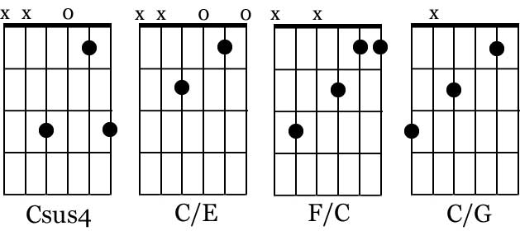
Love Me Anymore

Intro.: |(C) / / (Csus4)| x 2

(C) I'll be the bad guy, (Csus4) (C) I'll take the black eye (Csus4)
(C) When I walk out, you can slam the (F) door
I'll be the S.O.B, (C) if that's what you (Am)need from me
So (G)you don't have to love me any-(C)more (G7)

(C) When you and our friends talk, (Csus4) (C) make it all my fault (Csus4)
(C) Tell 'em I'm rotten (C/E) to the (F)core (C)
(F) I'll let it all slide, (C) get 'em all on (Am)your side
So (G)you don't have to love me any-(C)more

(Chorus)
(F)I will (F/C)keep all those (F) memories of the (C)good times
(C/G) Yeah, there were some good (C) times
So (F)when you (F/C)think of (Dm)you and me
(G) They won't even cross your mind

(C) If the wine your (C/G)drinkin', (C) leads you to (C/G)thinkin'
(C) That you want (C/E)what we (G)had be-(F)fore (F/C)
(F) Girl you can call me, (C) I'll let it (Am)ring and ring
So (G)you don't have to love me any-(C)more (C/G)

Inst.: |(C)(C/G)|(C)(C/G)|(C)(C/G)|(F) |(F) |(C)(Am)|(G) |(C) |

(Chorus)
(F)I will (F/C)keep all those (F) memories of the (C)good times
(C/G) Yeah, there were some good (C) times
So (F)when you (F/C)think of (Dm)you and me
(G) They won't even cross your mind

(Tag)
(F) If you need me to make you cry, (C) I don't want to but (Am)I'll try
So (G)you don't have to love me any-(C)more / (C/G)(Csus4)|(C) / (C/G)(Csus4)|(C) -----

